Summer Souvenirs
Bring in one thing that tells about something you did this summer.

It could be...

• A photo of you and/or family member

• A postcard, t-shirt, or other item
from somewhere you visited

• Something you found that reminds you of your summer event
(a seashell, for example)

• A story about something that happened to you (no object)
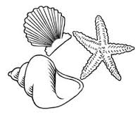

Be prepared to share with the class what the object had to do with your summer vacation or to retell the story to the class.

This assignment is due by Thursday, but we will start to share as soon as students start bringing things in.

Assignment #2: Learn your street address.

