Name: _________________
Exploring Magnets
Station 1
Q: Do magnets work through other non-magnetic materials?
Capture as many paperclips as possible to the bottom of the magnet. Then do the same through each material. Record the number of paperclips picked up.

# of paperclips
Just the magnet
Paper pad in between
Book in between
Plastic clipboard in between
Glass in between
Other _______________

Station 2
Q. What poles attract and what poles repel?
Use magnets to test which pairs will attract and which pairs repel each other. Circle your answers.
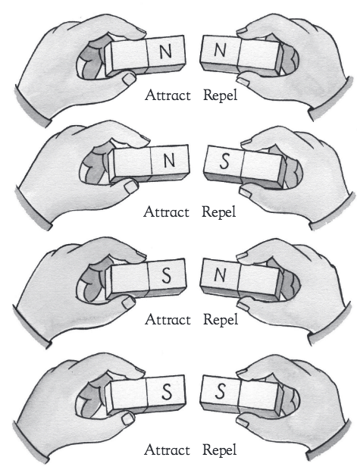

Station 3 Teacher Demonstration
Q: Do magnets work when magnetic materials are mixed with other materials?
Mix sugar and iron fillings.
Do you think they will separate? _____ yes _____ no
Try to separate with your wand. Could you separate? _____yes _____no

Station 4
Q: What does a magnetic field look like?
1. Place a magnet on a flat surface. Lay a piece of paper over the magnet so that the magnet is centered under the paper.
2. Lightly sprinkle the iron filings onto the paper over the magnet.
3. Draw the magnetic lines of force coming from the magnet? Can you see the strongest part of the magnet?

N
S

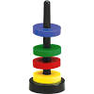
Station 5 Ring Magnets

Q: Can you float all magnets? _____ yes _____ no

Q: Can you group them in 2s? _____ yes _____ no

Station 6

Design an experiment with magnets from the trays. Describe what you did and what you found out.
______________________________________________________________
______________________________________________________________
______________________________________________________________
______________________________________________________________

