Name:

To get ready for our Amazing Adventure tomorrow, today we will go on a
Virtual Tour of the Amazement Square Website

Navigate to the Amazement Square Web Site via our Weebly.

1) How long will it take to get to Amazement Square?

Under Visit Click on the Map and View Larger. Our address is 1407 Crozet Ave. 22932 _________________________

10:00-10:15 Orientation

10:20-10:50 Exhibit Exploration

There is so much to see at the exhibits, so we will have to plan carefully. Click on Exhibitions and use the map to go to each exhibit. Look at the pictures and/or read the words to find out something about the exhibits.

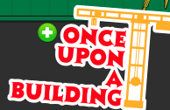
Once Upon a Building (4th Floor)

At Once Upon a Building I want to ______________________________________________________________________

_____________________________________________________________________________________________________________

On the James (4th Floor)
At On the James I want to ________________________________________________________________________________

_____________________________________________________________________________________________________________

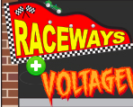
Raceways and Voltageville (3rd Floor)

At Raceways and Voltageville I want to ________________________________________________________________

_________________________________________________________________________________________________________________

The League of Healthy Heroes (3rd Floor)

At The League of Healthy Heroes what vehicle can you ride?

Shipwreck Cove! and The Big Red Barn (3rd Floor)

For what age is Shipwreck Cove? _________

Big Red Barn (2nd Floor/Lobby Floor)

Look at the Big Red Barn pictures. For what age so you think this exhibit is for? __________

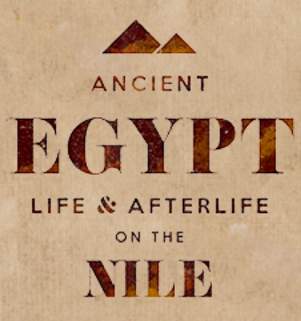
Ancient Egypt: Life on the Nile (2nd Floor/Lobby Floor)

Since you will be studying Egypt next year, this is one exhibit you will not want to miss! It is in the changing exhibit area. Read the last sentence of the 1st paragraph. What is one thing you would like to do?

__________________________________________________________________________________________________________________________

The Art of Acting (1st Floor/Basement)

At The Art of Acting the part I want to do most is...

_____________________________________________________________________________________________________________
(Read the last sentence of the description paragraph or the map caption!)

Kaleidoscope Gallery (1st Floor / Basement)

At the Kaleidoscope Gallery, there are actually 4 separate parts.

At the Kaleidoscope Gallery the part(s) I want to see most is

__________________________________________________________________________________________________________________________________________

10:55-11:25 Tower Explorations
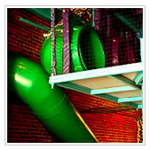
There is so much to do at the Tower. Click on Exhibitions and use the map to visit each floor of the tower.
The Tower

How many floors is the tower? _________________________________

At the tower I want to ___________________________________________________________________________________________

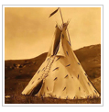
11:30-12:00 Native American Cultures, NA Gallery, 4th Floor

Go back to Exhibitions and go to the Native American Gallery. Look at the pictures and/or read the words to find out something about this exhibit.

At the Native American exhibit the part I want to see most is __________________________________________

_______________________________________________________________________________________________________________

12:05-12:35 Lunch, Imagination Studio, 1st Floor

12:35 Departure

After discussing with the class, write 3 expectations you need to remember on the field trip.

1. __________________________________________________________________________________________________________________________

2. __________________________________________________________________________________________________________________________

3. __________________________________________________________________________________________________________________________

