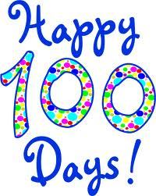

What can you do in 100 seconds?

How many jumping jacks? Estimate ____ Actual ____

How many one-handed
catches with a tennis ball? Estimate ____ Actual ____

How many partner catches
with a tennis ball? (1 meter apart) Estimate ____ Actual ____

How many baskets with a paper ball? Estimate ____ Actual ____
How many paper cups stacked? Estimate ____ Actual ____
Other: _____________________ Estimate ____ Actual ____
Other: _____________________ Estimate ____ Actual ____
