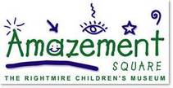 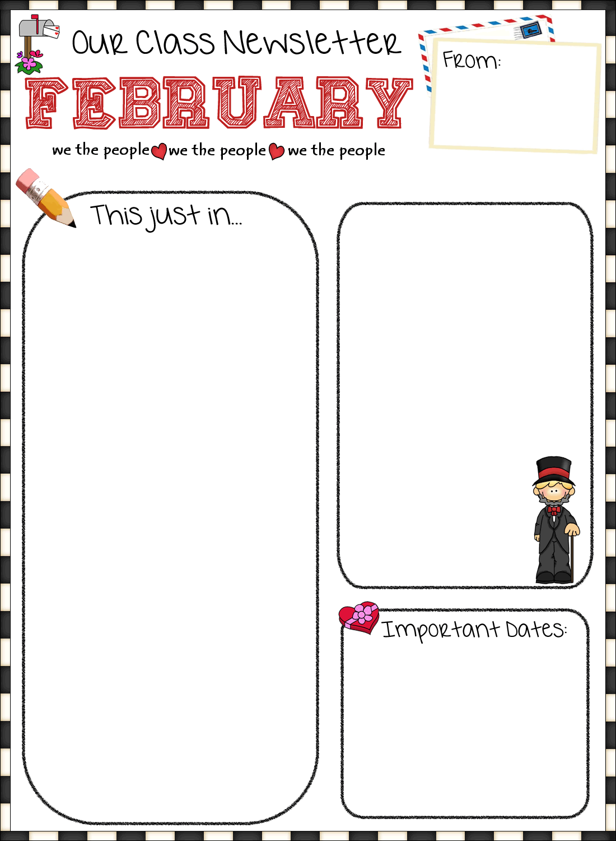

LAST WEEKS’ HIGHLIGHTS

**Reading:** *The Pueblo*, *Koko’s Kittens, Toys Go Out*

**Writing:** Writing wondering questions about non-fiction text**,** notes and illustrations on the Pueblo

**Math:** Begin *Favorites* Data Project, subtraction with tens and ones using manipulatives and traditional subtraction with regrouping

**Science/SS:** the Pueblo Indians, guidance with Ms. Joyner: Using a Social Filter

**Other Fun Stuff:** 100th Day of School Activities, STEM: Lego LearnToLearn *Block and Cover* math game

Site of the Week

http://www.amazementsquare.com/

**HAPPY**

**BIRTHDAY**

**Hill 2/16**

A MESSAGE FROM MRS. JOYNER

This week is Random Acts of Kindness Week. We have lots of fun activities planned to celebrate Crozet kindness! We will start our celebration by having some themed days to get everyone in the spirit!

Monday: Hats off to Kindness: Wear a hat!

Tuesday: Telephone Tuesday: Call someone to let

them know you were thinking of them.

Wednesday: You can’t beat kindness: Wear your favorite sports attire!

Thursday: Thank you Thursday: Write a thank you note to let someone know you appreciate them!

Friday: Crazy kind Crozet kids: Crazy hair day!

Thank you so much for your support! –Mrs. Joyner

Mon: Fluency Questions

Counts as 20 min. reading on log

Tue: Read 20+ min. & 1 min. fluency

Wed: Read 20+ min. & 1 min. fluency

Thur: Read 20+ min.

Study for Friday’s word study test

Fri: Read 20+ min. sometime this weekend

.

Feb. 13-18 RAK Week...see daily events in the *This just in*... box.

Feb. 14 Valentine’s Day Party

Feb. 15 Jump Rope for Heart

Feb. 16 Amazement Square Field Trip 8:00-2:15

Feb. 20 Weather Make-Up Day

Feb. 23 Digital Learning Day

March 3 2-3 Music Performance

WEBPAGE

huneycutt.

weebly.com

CONTACT INFO

bhuneycutt@

k12albemarle.org

434-823-4800

**Issue 23: February 13, 2017**

THIS WEEK’S HOMEWORK

TYPE CONTENT HERE…

Mrs. Huneycutt’s Class Crozet Elementary  
Grade 2