Name:

To get ready for our Amazing Adventure tomorrow, today we will go on a
Virtual Tour of the Amazement Square Website

Navigate to the Amazement Square Web Site via our Weebly.

1) How long will it take to get to Amazement Square?

Under Visit Click on the Map, then Directions. Our address is 1407 Crozet Ave. 22932 _________________________

10:00-10:10 Orientation

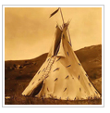
10:20-10:50 Native American Cultures, NA Gallery, 4th Floor

Go back to Explore and go to the Native American Gallery. Look at the pictures and/or read the words to find out something about this exhibit.

At the Native American exhibit the part I want to see most is __________________________________________

_______________________________________________________________________________________________________________

10:55-11:25 Lunch, Imagination Studio, 1st Floor
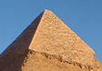
11:30-12:00 Deserts and Dynasties, Community Room, 4th Floor

Under Learn and Amazing Adventures School Programs click on the Deserts and Dynasties link.

What two countries will we learn about? _______________________________ ____________________________________

12:05-12:35 Exploration
There is so much to see at the Tower and other Exhibits, so we will have to plan carefully. Click on Explore and use the map to go to each exhibit. Look at the pictures and/or read the words to find out something about the exhibits.
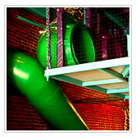
The Tower

How many floors is the tower? _________________________________

At the tower I want to ___________________________________________________________________________________

_____________________________________________________________________________________________________________

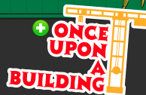
Once Upon a Building

At Once Upon a Building I want to ______________________________________________________________________

_____________________________________________________________________________________________________________

On the James
At On the James I want to ________________________________________________________________________________

_____________________________________________________________________________________________________________

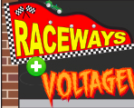
Raceways and Voltageville

At Raceways and Voltageville I want to ________________________________________________________________

_________________________________________________________________________________________________________________

The League of Healthy Heroes

At The League of Healthy Heroes what vehicle can you ride?

____________________________________________________________________________________________

Shipwreck Cove! and The Big Red Barn

For what age is Shipwreck Cove? _________

Big Red Barn

Look at the Big Red Barn pictures. For what age so you think this exhibit is for? __________

Flights of Fancy

What animal will you learn about at Flights of Fancy? ________________________________________________________

The Art of Acting
At The Art of Acting the part I want to do most is

_____________________________________________________________________________________________________________
(Read the last sentence of the description paragraph or the map caption!)

Kaleidoscope Gallery

The Kaleidoscope Gallery, there are actually 4 separate parts.

At the Kaleidoscope Gallery the part(s) I want to see most is

__________________________________________________________________________________________________________________________________________

12:35 Departure

After discussing with the class, write 3 expectations you need to remember on the field trip.

1. __________________________________________________________________________________________________________________________

2. __________________________________________________________________________________________________________________________

3. __________________________________________________________________________________________________________________________

